South Bay Cities

Council of Governments

13th Annual General Assembly – February 24, 2012
“Be Prepared: Preventing Disasters/Planning for Recovery”

Bill Bogaard
Mayor
City of Pasadena
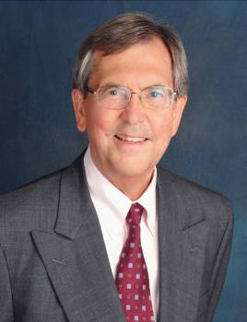
Bill Bogaard is in his fourth term as Mayor of Pasadena, after taking office in 1999 as the City’s first directly elected Mayor. The subsequent time has been an active period in the City’s history, involving the arrival of the Gold Line light rail transit system; significant investment in new housing; construction of a new convention center; establishment of new arts institutions; and reform of the public schools.

He serves as chair of Pasadena Bioscience Collaborative, a technology enterprise incubator and workforce development program, and the Emergency Services Council, City of Pasadena. He is a member of the Gold Line Foothill Construction Authority and the Urban Land Institute.

Mayor Bogaard graduated from Loyola Marymount University. After serving as a U.S. Air Force Captain, he graduated from Michigan Law School. He is a Board member of the Pasadena Educational Foundation and the Pasadena YMCA. In 1997, the City of Pasadena granted him its highest civic recognition, the Arthur Noble Award.

In the private sector, Mayor Bogaard engaged in private law practice, and then served as Executive Vice President of First Interstate Bancorp. He serves as an arbitrator of business disputes and has taught law at the University of Michigan and USC Law

